**CA3001 – Programming and Data Structure using C**

**Assignment : 3 (28.12.2020)**

**Q1.** Display multiple variables.

Ans - C Program & Output:

#include <stdio.h>

int main()

{

int a = 125, b = 12345;

long ax = 1234567890;

short s = 4043;

float x = 2.13459;

double dx = 1.1415927;

char c = 'W';

unsigned long ux = 2541567890;

printf("a + c = %d\n", a + c);

printf("x + c = %f\n", x + c);

printf("dx + x = %f\n", dx + x);

printf("((int) dx) + ax = %ld\n", ((int) dx) + ax);

printf("a + x = %f\n", a + x);

printf("s + b = %d\n", s + b);

printf("ax + b = %ld\n", ax + b);

printf("s + c = %hd\n", s + c);

printf("ax + c = %ld\n", ax + c);

printf("ax + ux = %lu\n", ax + ux);

return 0;

}

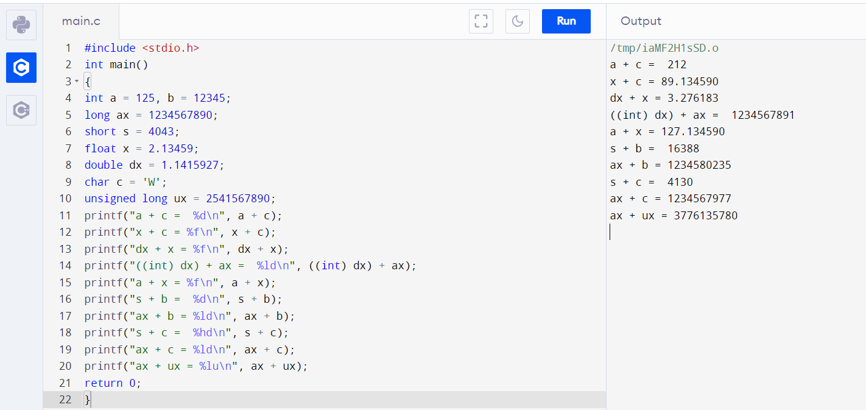

**Q2**. Convert specified days into years, weeks and day.

Ans - C Program & Output:

#include <stdio.h>

int main()

{

int days, years, weeks;

printf("Enter days: ");

scanf("%d",&days);

years = days/365;

weeks = (days % 365)/7;

days = days- ((years*365) + (weeks*7));

printf("Years: %d\n", years);

printf("Weeks: %d\n", weeks);

printf("Days: %d \n", days);

return 0;

}

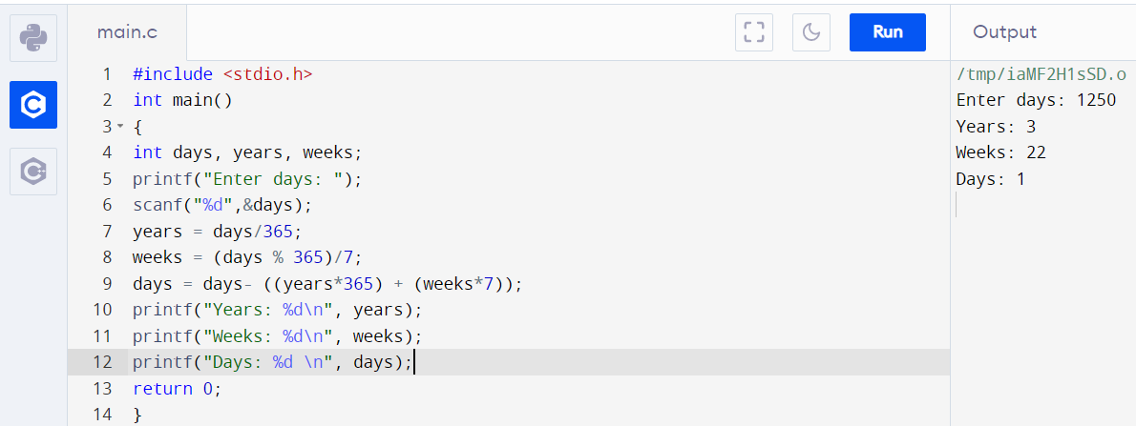

**Q3.** Accepts two item’s weight (floating points' values ) and number of purchase (floating points' values) and calculate the average value of the item

Ans - C Program & Output:

#include <stdio.h>

int main()

{

float wi1, ci1, wi2, ci2, result;

printf("Weight - Item1: ");

scanf("%f", &wi1);

printf("No. of item1: ");

scanf("%f", &ci1);

printf("Weight - Item2: ");

scanf("%f", &wi2);

printf("No. of item2: ");

scanf("%f", &ci2);

result = ((wi1 * ci1) + (wi2 * ci2)) / (ci1 + ci2);

printf("Average Value = %f\n", result);

return 0;

}

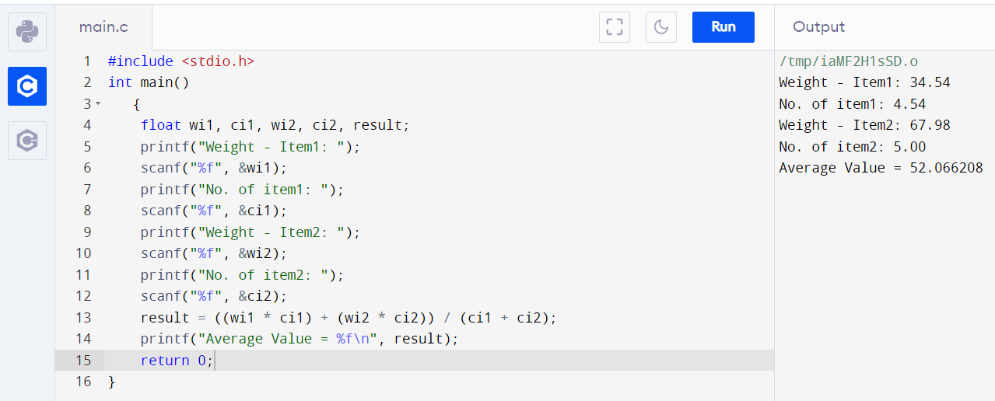

**Q4.** Create enumerated data type for 7 days and display their values in integer constant

Ans - C Program & Output:

#include <stdio.h>

int main()

{

enum week{Sun, Mon, Tue, Wed, Thu, Fri, Sat};

printf("Sunday = %d", Sun);

printf("\nMonday = %d", Mon);

printf("\nTuesday = %d", Tue);

printf("\nWednesday = %d", Wed);

printf("\nThursday = %d", Thu);

printf("\nFriday = %d", Fri);

printf("\nSaturday = %d", Sat);

return 0;

}

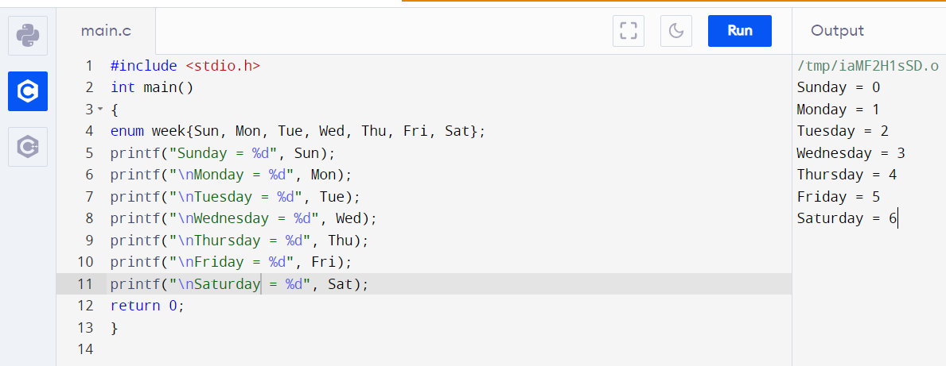

**Q5.** Converts Centigrade to Fahrenheit

Ans - C Program & Output:

#include<stdio.h>

int main()

{

float fahrenheit, celsius;

printf("Enter temperature in centigrade:");

scanf("%f",&celsius);

fahrenheit =( (celsius*9)/5)+32;

printf("\n\n Temperature in fahrenheit is: %f",fahrenheit);

return 0;

}

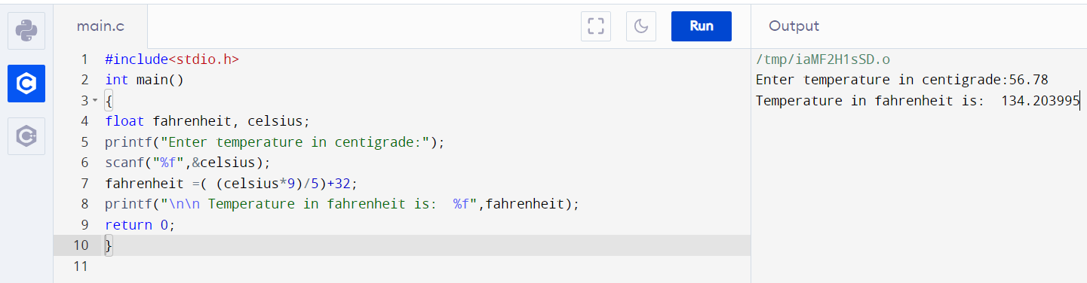

**Q6.** Takes minutes as input, and display the total number of hours and minutes

Ans – C Program & Output:

#include<stdio.h>

int main()

{

int minute;

printf("\n\n\tEnter minutes = ");

scanf("%d",&minute);

printf("\nEntered minutes = %d minutes \n Which is equivalent to = %d hours and %d minutes",minute,minute/60,minute%60);

return 0;

}

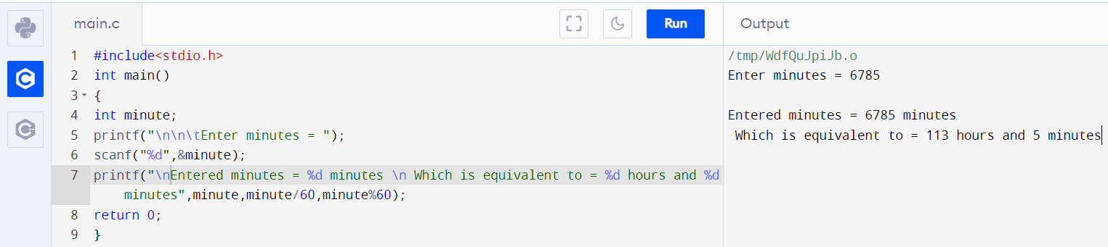

**Q7**. Print the perimeter of a rectangle to take its height and width as input

Ans - C Program & Output:

#include<stdio.h>

int main()

{

float height, width, perimeter;

printf("Enter the height and width of the rectangle:\n");

scanf("%f%f",&height,&width);

perimeter = 2*(height+width);

printf("Perimeter of the given rectangle is : %f",perimeter);

return 0;}

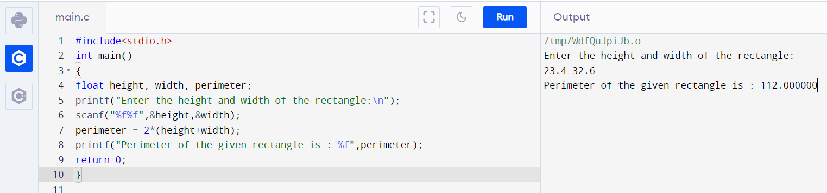

**Q8.** By using +, /, %=, >=, ! operator

Ans - C Program & Output:

#include<stdio.h>

int main()

{

int a = 9,b = 4, c;

c = a+b;

printf("a+b = %d \n",c);

c = a/b;

printf("a/b = %d \n",c);

c %= a;

printf("c = %d\n", c);

printf("%d >= %d is %d \n", a, b, a >= b);

printf("%d != %d is %d \n", a, b, a != b);

return 0;

}

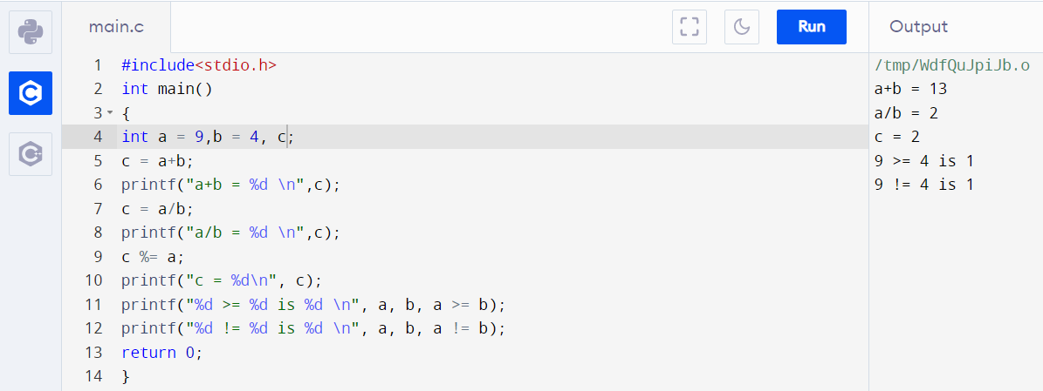

**Q9.** By using &, |, >>, || operators

Ans – C Program & Output:

#include <stdio.h>

int main()

{

int a = 12, b = 25, c = 23, result;

printf("Bitwise And = %d\n", a&b);

printf("Bitwise Or = %d\n", a|b);

printf("Right shift by %d: %d\n", a, a>>2);

result = (a == b) || (c < b);

printf("(a == b) || (c < b) is %d \n", result);

return 0;

}

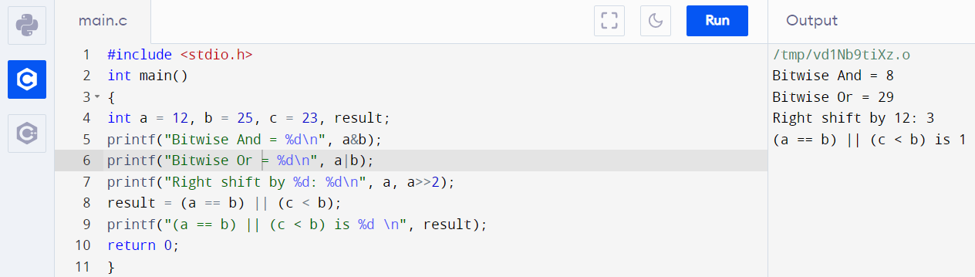

**Q10.** Find the Size of int, float, double and char

Ans – C Program & Output:

#include <stdio.h>

int main()

{

int a;

float b;

double c;

char d;

printf("Size of int=%lu bytes\n",sizeof(a));

printf("Size of float=%lu bytes\n",sizeof(b));

printf("Size of double=%lu bytes\n",sizeof(c));

printf("Size of char=%lu byte\n",sizeof(d));

return 0;

}

